**Chapter III**

**RESEARCH AND METHODOLOGY**

**3.0 Method of development**

In comparison between the existing and our newly proposed point of sale system is that we conducted a research study for all the downloadable POS from internet, we notice that there are some interfaces which is not user friendly, other applications are available online and can browse only for desktops, it has also limited features such as vend and retail man point of sale. We observe and try all the functionalities for every available module they have, we also study any possible features that can cover the specific business that can reach our limitations to improve that system. And for that research we had gathered information for every establishment that has a common products and services transaction to fuse different modules in one system. And for this system we used the incremental model for the step by step process of the modules. The modules are drafted according to the level of priority. Every module is a standalone function and has to be developed according to the implementation progression of the project.

**Diagram of Incremental model:**

[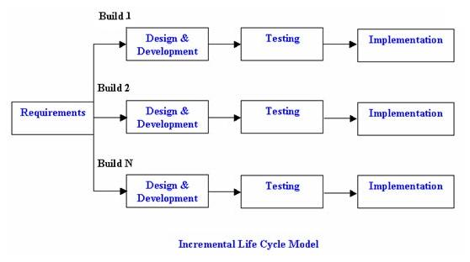](http://istqbexamcertification.com/wp-content/uploads/2012/01/Incremental_model.jpg)

This diagram shows the related step by step process of the development of the Point of Sale system.

**Entity Relationship Diagram**

This table shows the relationship of every table in the database.

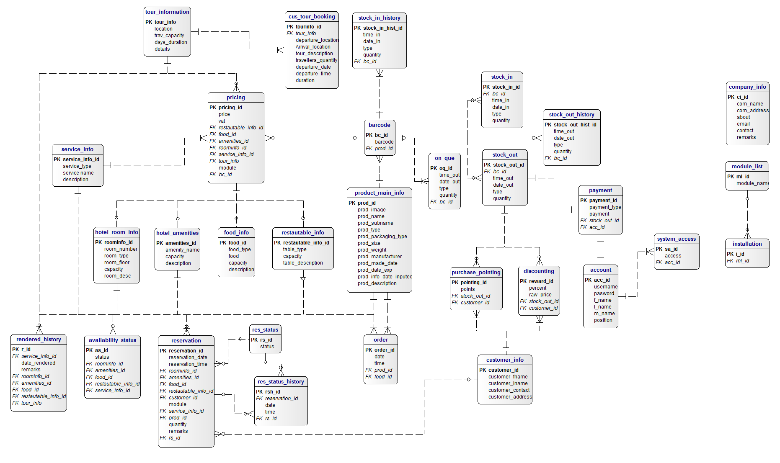

**DATA DICTIONARY**

|  |  |  |  |
| --- | --- | --- | --- |
| **P/F** | **Field Name** | **Caption** | **Data Type** |
| **P** | **Prod_id** | **Product ID** | Integer |
|  | Prod_image | Product Image | Varchar |
|  | Prod_name | Product_name | Varchar |
|  | Prod_subname | Product Subname | Varchar |
|  | Prod_type | Type of Product | Varchar |
|  | Prod_packaging_type | Type of Package | Varchar |
|  | Prod_size | Size | Varchar |
|  | Prod_weight | Weight | Varchar |
|  | Prod_manufacturer | Manufacturer | Varchar |
|  | Prod_made_date | Made Date | Varchar |
|  | Prod_date_exp | Expire Date | Varchar |
|  | Prod_info_date_inputed | Inputed Date | Varchar |
|  | Prod_description | Description | Text |
|  | Address | Address | Varchar |
|  |  |  |  |

**Product Main Information**

|  |  |  |  |
| --- | --- | --- | --- |
| **P/F** | **Field Name** | **Caption** | **Data Type** |
| **P** | **Bc_code** | **Barcode ID** | Integer |
|  | Barcode | Product Barcode | Integer |
| F | Prod_id | Product ID |  |
|  |  |  |  |
|  |  |  |  |

**Barcode**

**Tour Information**

|  |  |  |  |
| --- | --- | --- | --- |
| **P/F** | **Field Name** | **Caption** | **Data Type** |
|  |  |  |  |
|  |  |  |  |
|  |  |  |  |
|  |  |  |  |
|  |  |  |  |

**Customer Tour Booking**

|  |  |  |  |
| --- | --- | --- | --- |
| **P/F** | **Field Name** | **Caption** | **Data Type** |
| **P** | Tour_info | Information | Integer |
|  | Location | Location | Varchar |
|  | Trav_capacity | Capacity | Varchar |
|  | Days_duration | Duration | Varchar |
|  | Details | Tour Details | Text |

|  |  |  |  |
| --- | --- | --- | --- |
| **P/F** | **Field Name** | **Caption** | **Data Type** |
| **P** | Tourinfo_id | Information ID | Integer |
|  | Departure_location | Departure Location | Varchar |
|  | Arrival_location | Arrival Location | Varchar |
|  | Tour_description | Description | Text |
|  | Travellers_quantity | No. of travellers | Varchar |
|  | Departure_time | Time | Varchar |
|  | Departure_date | Date | Varchar |
|  | Duration | Total Duration | Varchar |
| **F** | Tour_info | Information | varchar |

|  |  |  |  |
| --- | --- | --- | --- |
| **P/F** | **Field Name** | **Caption** | **Data Type** |
| **P** | Roominfo_id | Room ID | Integer |
|  | Room_number | Room Numbers | Varchar |
|  | Room_type | Room Type | Varchar |
|  | Room_floor | Room Floor | Varchar |
|  | Capacity | Total Capacity | Varchar |
|  | Room_desc | Description | Text |

**Hotel Room Information**

**Hotel Amenities**

|  |  |  |  |
| --- | --- | --- | --- |
| **P/F** | **Field Name** | **Caption** | **Data Type** |
| **P** | Amenities_id | Amenities ID | Integer |
|  | Amenity_name | Amenity Name | Varchar |
|  | Capacity | Capacity | Varchar |
|  | description | Description | Text |

**Food Info**

|  |  |  |  |
| --- | --- | --- | --- |
| **P/F** | **Field Name** | **Caption** | **Data Type** |
| **P** | Food_id | Food ID | Integer |
|  | Food_type | Type of Food | Varchar |
|  | Food | Name of Food | Varchar |
|  | Capacity | No. of person | Varchar |
|  | description | Description | Text |

**Restaurant Table Info**

|  |  |  |  |
| --- | --- | --- | --- |
| **P/F** | **Field Name** | **Caption** | **Data Type** |
| **P** | Restautable_info_id | Table Information | Integer |
|  | Table_type | Type of Table | Varchar |
|  | Capacity | Table Capacity | Varchar |
|  | Table_description | Description | Text |

|  |  |  |  |
| --- | --- | --- | --- |
| **P/F** | **Field Name** | **Caption** | **Data Type** |
| **P** | Stock_in_id | Stock-in ID | Integer |
|  | Time_in | Time-In | Varchar |
|  | Date_in | Date Arrived | Varchar |
|  | Type | Type of Product | Varchar |
|  | Quantity | No. of Products | Varchar |
| **F** | Prod_id | Product ID | Integer |

**Stock-in**

|  |  |  |  |
| --- | --- | --- | --- |
| **P/F** | **Field Name** | **Caption** | **Data Type** |
| **P** | Stock_out_id | Stock-out ID | Integer |
|  | Time_out | Time-out | Varchar |
|  | Date_out | Date-out | Varchar |
|  | Type | Product Type | Varchar |
|  | Quantity | No. of Products | Varchar |
| **F** | Prod_id | Product ID | Integer |

**Stock-out**

**Payment**

|  |  |  |  |
| --- | --- | --- | --- |
| **P/F** | **Field Name** | **Caption** | **Data Type** |
| **P** | Payment_id | Payment ID | Integer |
|  | Payment_type | Type of Payment | Varchar |
|  | Payment | Total Payment | Varchar |
| **F** | Stock_out_id | Stock out ID | Integer |
| **F** | Acc_id | Account ID | Integer |

|  |  |  |  |
| --- | --- | --- | --- |
| **P/F** | **Field Name** | **Caption** | **Data Type** |
| **P** | Pricing_id | Pricing ID | Integer |
|  | Price | Price | Integer |
|  | Vat | VAT | Varchar |
| F | Prod_id | Product ID | Integer |
| F | Restautable_info_id | Table Information | Integer |
| F | Food_id | Food Information | Integer |
| F | Amenities_id | Amenities ID | Integer |
| F | Room_info | Room Information | Varchar |
| F | Service_info_id | Service information | Integer |
| F | Tour_info | Tour Information | Varchar |
| F | module | Module | Varchar |

**Pricing**

**Purchase pointing**

|  |  |  |  |
| --- | --- | --- | --- |
| **P/F** | **Field Name** | **Caption** | **Data Type** |
| **P** | Pointing_id | Pointing ID | Integer |
|  | Points | Total points | Integer |
| **F** | Stock_out_id | Stock out ID | Integer |
| **F** | Customer_id | Customer ID | Integer |

|  |  |  |  |
| --- | --- | --- | --- |
| **P/F** | **Field Name** | **Caption** | **Data Type** |
| **P** | Reward_id | Reward ID | Integer |
|  | Percent | Percent | Varchar |
|  | Raw_price | Raw Price | Integer |
| **F** | Stock_out_id | Stock out ID | Integer |
| **F** | Customer_id | Customer ID | integer |

**Discounting**

**Customer info**

|  |  |  |  |
| --- | --- | --- | --- |
| **P/F** | **Field Name** | **Caption** | **Data Type** |
| **P** | Customer_id | **Customer ID** | Integer |
|  | Customer_fname | First Name | Varchar |
|  | Customer_lname | Last Name | Varchar |
|  | Customer_contact | Contact Number | Integer |
|  | Customer_address | Address | Varchar |

**Reservation**

|  |  |  |  |
| --- | --- | --- | --- |
| **P/F** | **Field Name** | **Caption** | **Data Type** |
| **P** | Reservation_id | **Reservation ID** | Integer |
|  | Reservation_date | Reservation Date | Integer |
|  | Reservation_time | Reservation Time | Integer |
| **F** | Roominfo_id | Room Information ID | Integer |
| **F** | Amenities_id | Amenities ID | Integer |
| **F** | Food_id | Food ID | Integer |
| **F** | Restautable_info_id | Restaurant Information | Integer |
| **F** | Customer_id | Customer ID | Integer |
|  | Module | Module | Varchar |
| **F** | Service_info_id | Service Information | Integer |
| **F** | Prod_id | Product ID | Integer |
|  | Quantity | No. of Persons | Integer |
|  | Remarks | Remarks | Varchar |

|  |  |  |  |
| --- | --- | --- | --- |
| **P/F** | **Field Name** | **Caption** | **Data Type** |
| **P** | Order_id | Order ID | Integer |
|  | Date | Date | Varchar |
|  | Time | Time | Varchar |
| **F** | Prod_id | Product ID | Integer |
| **F** | Food_id | Food ID | Integer |

**Order**

**Account**

|  |  |  |  |
| --- | --- | --- | --- |
| **P/F** | **Field Name** | **Caption** | **Data Type** |
| **P** | Acc_id | Account ID | Integer |
|  | Username | Username | Varchar |
|  | Password | Password | Varchar |
|  | F_name | First Name | Varchar |
|  | L_name | Last Name | Varchar |
|  | M_name | Middle Name | Varchar |
|  | Position | Position | Varchar |

|  |  |  |  |
| --- | --- | --- | --- |
| **P/F** | **Field Name** | **Caption** | **Data Type** |
| **P** | Sa_id | Access ID | Integer |
|  | Access | Access | Varchar |
| **F** | Acc_id | Account ID | Integer |

**System access**

|  |  |  |  |
| --- | --- | --- | --- |
| **P/F** | **Field Name** | **Caption** | **Data Type** |
| **P** | Stock_in_hist_id | Stock-in History | Integer |
|  | Time_in | Time In | Varchar |
|  | Date_in | Date In | Varchar |
|  | Type | Type | Varchar |
|  | Quantity | Quantity | Varchar |
| **F** | Prod_id | Product ID | Integer |

**Stock in history**

**Stock out history**

|  |  |  |  |
| --- | --- | --- | --- |
| **P/F** | **Field Name** | **Caption** | **Data Type** |
| **P** | Stock_out_hist_id | Stock-out History | Integer |
|  | Time_out | Time out | Varchar |
|  | Date_out | Date out | Varchar |
|  | Type | Type | Varchar |
|  | Quantity | Quantity | Varchar |
| **F** | Prod_id | Product ID | Integer |

**Service info**

|  |  |  |  |
| --- | --- | --- | --- |
| **P/F** | **Field Name** | **Caption** | **Data Type** |
| **P** | Service_info_id | Service ID | Integer |
|  | Service_type | Type of Service | Varchar |
|  | Service_name | Service Name | Varchar |

**Graphical User Interface**

**Inventory**

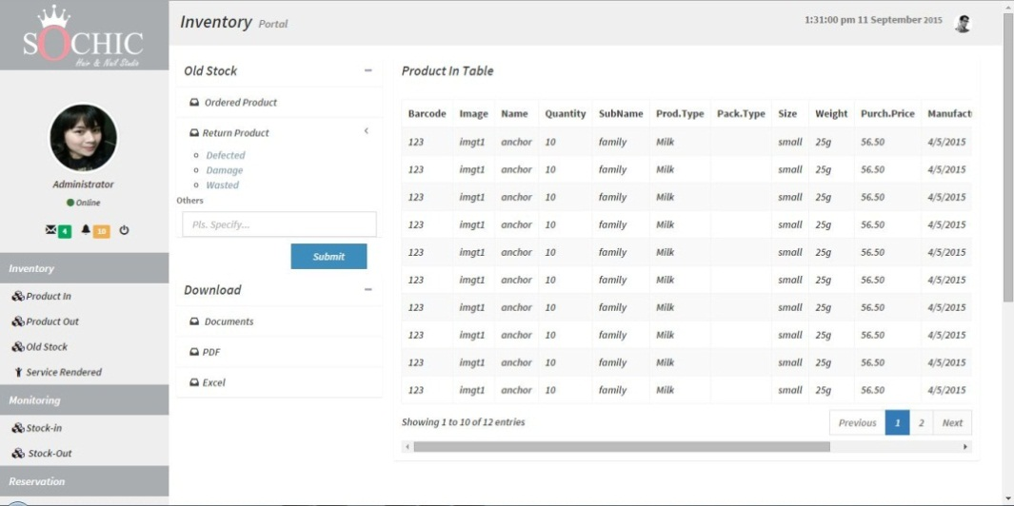

**This page shows contains all the records of the old stock.**

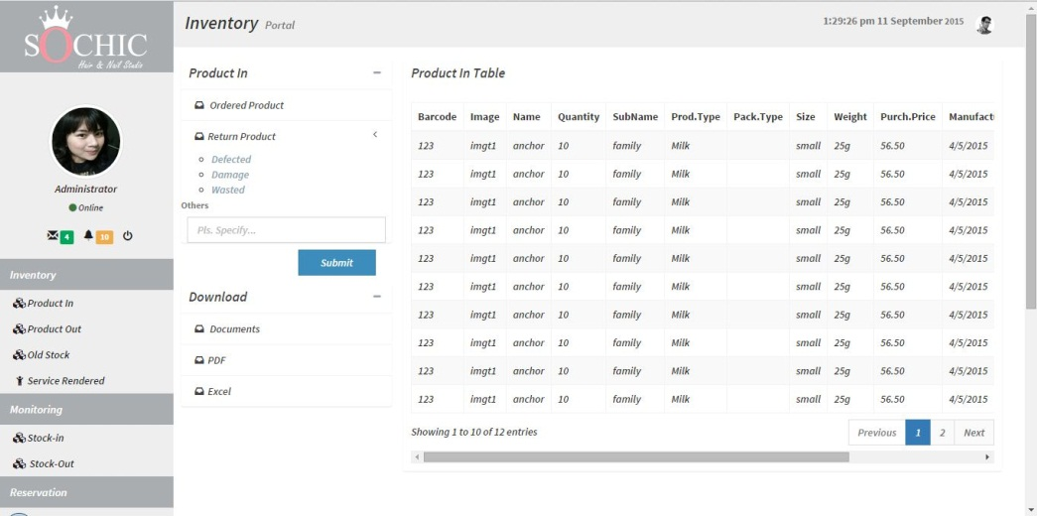

**This page shows where you can input new arrival products.**

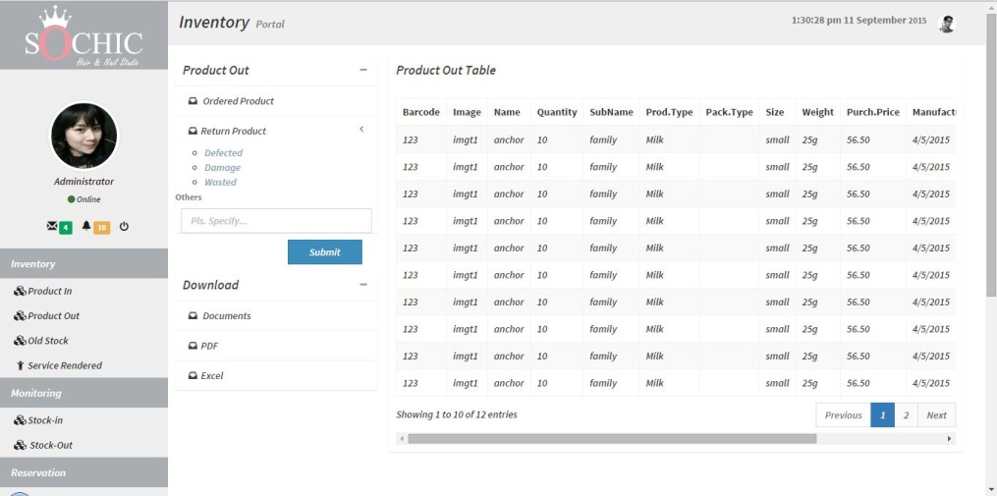

**This page shows where you can control the records of outgoing products.**

**Monitoring**

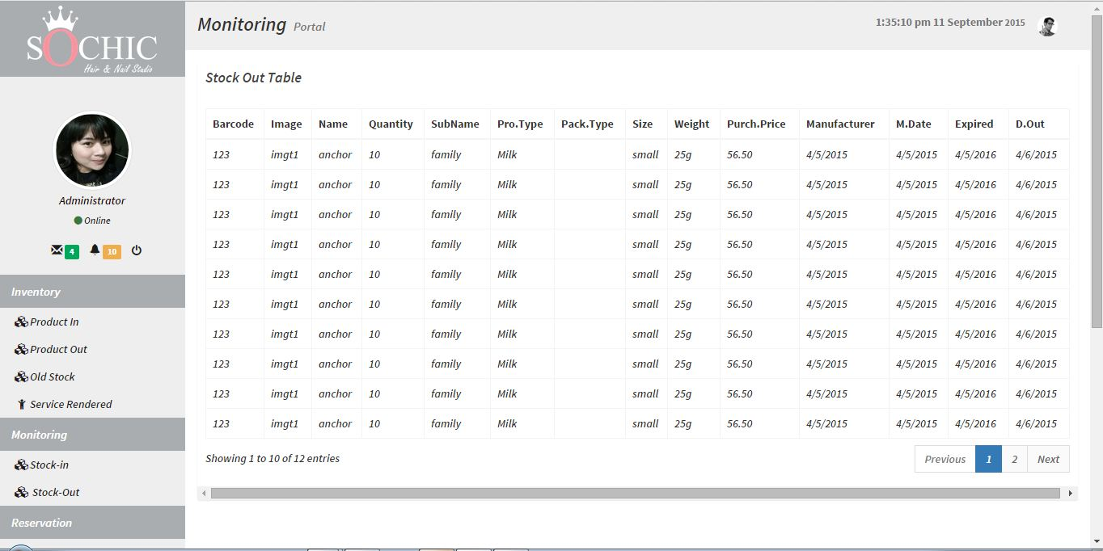

**This page shows where you can monitor the history of the product that already sold.**

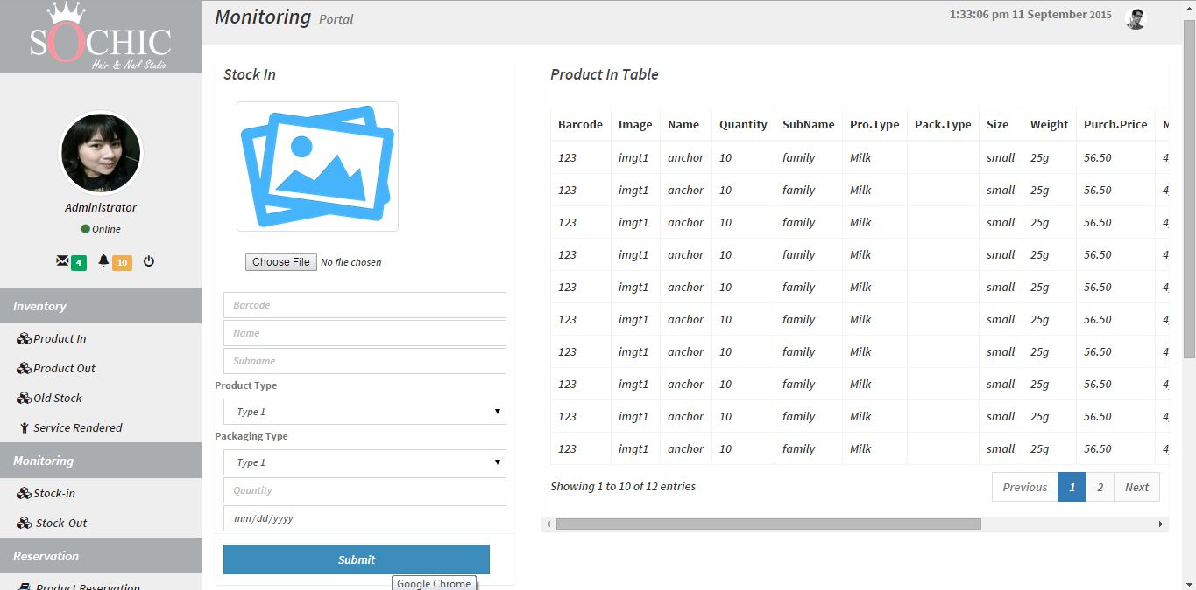

**This page shows where you can monitor all new inputed products.**

**Reservation**

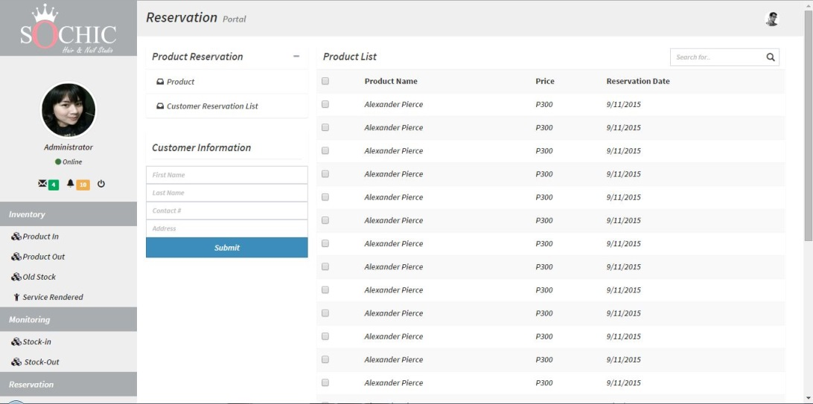

**This page shows where customers can make online reservation.**

**Sales Report**

**These pages show all the report for sales transactions.**

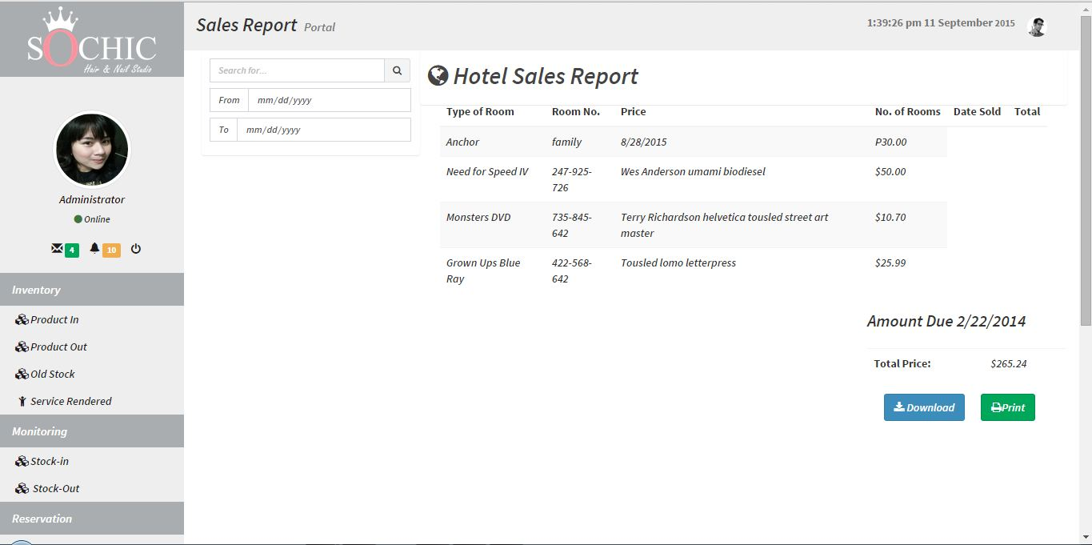

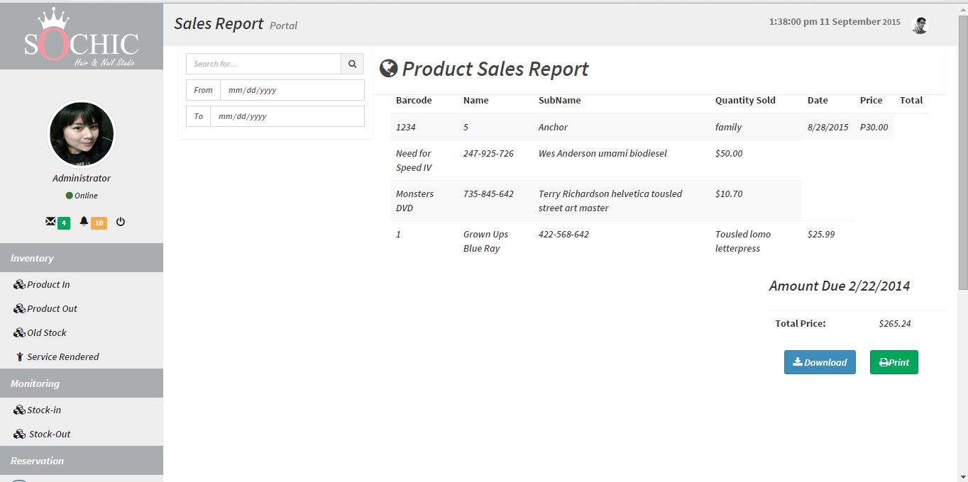

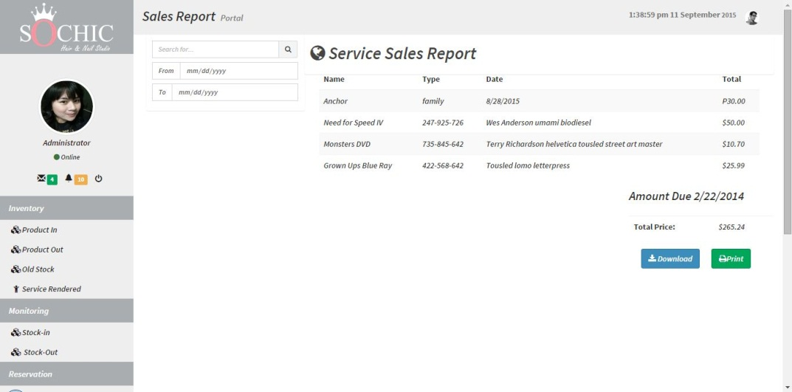

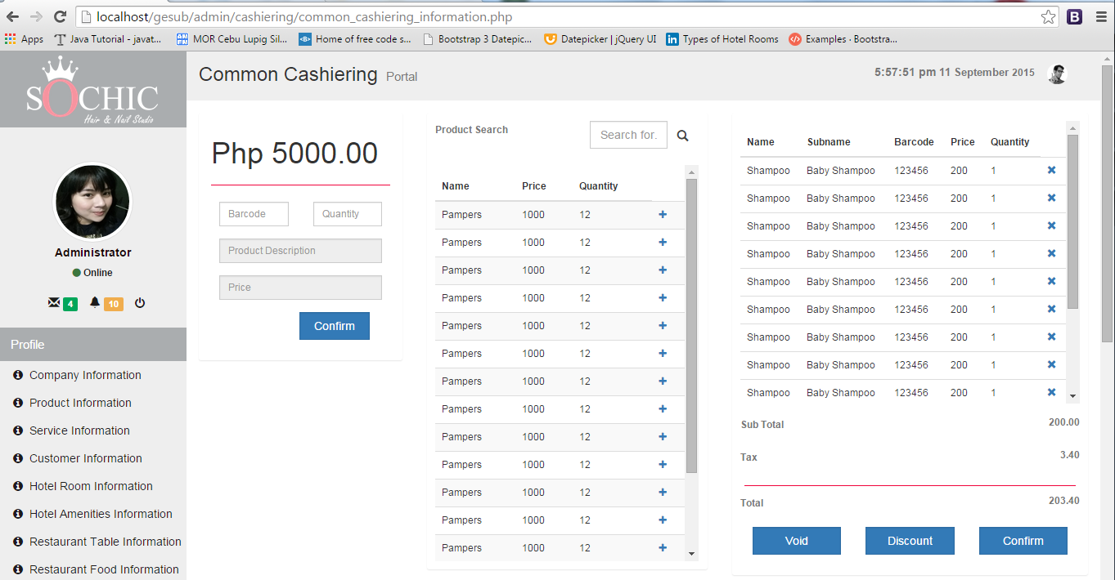**Cashiering**

**This page shows where the payment transactions made.**

**Security**

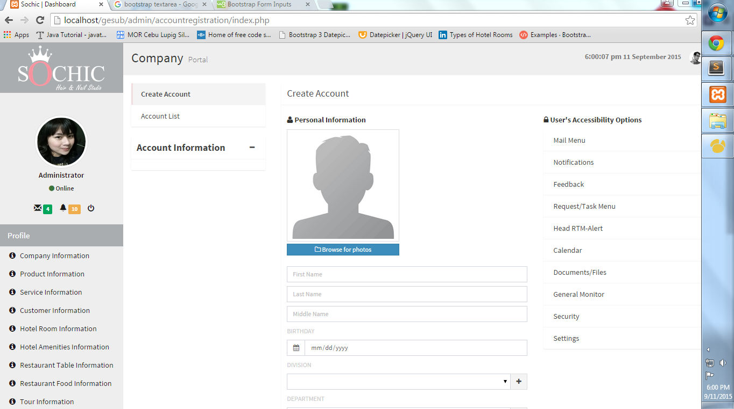

**This page is where the administrator can add an additional user that has authorized access to the system.**